Creek Valley – Short Track / Warm-up / Criterium Routes
Short-track: Standard Route = .5 Miles. 30’ Climbing
Short-track + Hill down to 9 mile creek and right back up = .65 Mi. 60’ Climbing.
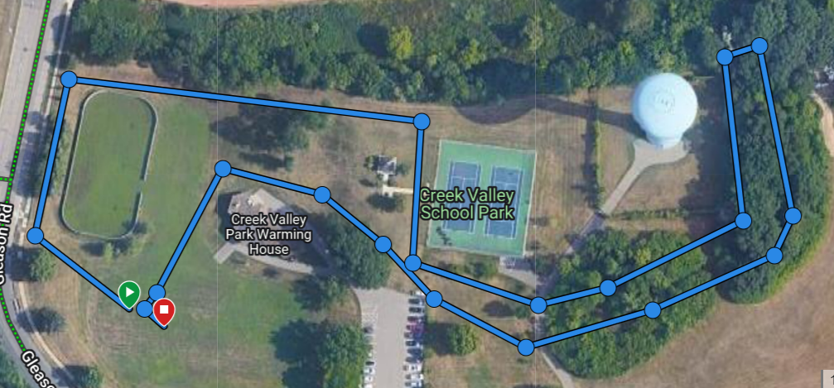

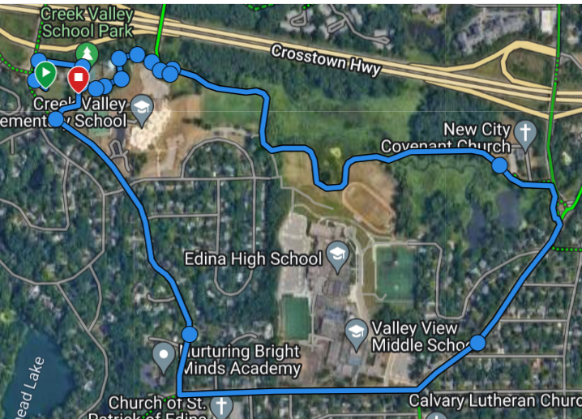

Warm-up: 2.75 Mi.
CV -> 9 Mile Creek ->
Tracy Ave -> Valley View ->
Gleason -> CV

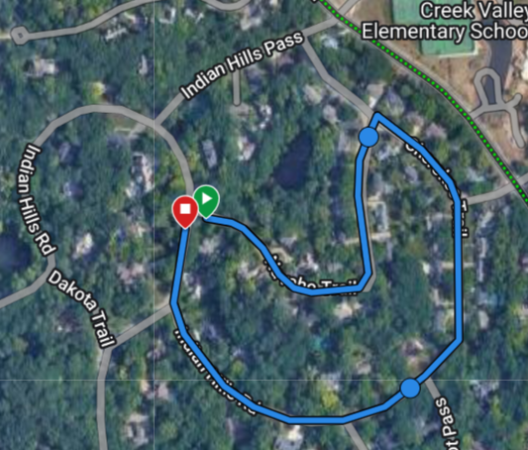

Creek Valley Criterium = .77 Miles
Suggest Counter Clockwise (all Right Turns)
Post Coach at Each intersection

Start: intersection of Navaho Trail & Indian Hills Rd.
- Right onto Cherokee Trail
- Stay Right. Turns into Indian Hills Rd.
- Right onto Navaho Trail for next lap.

Warm-up = 5.75 Miles. 257’ climbing
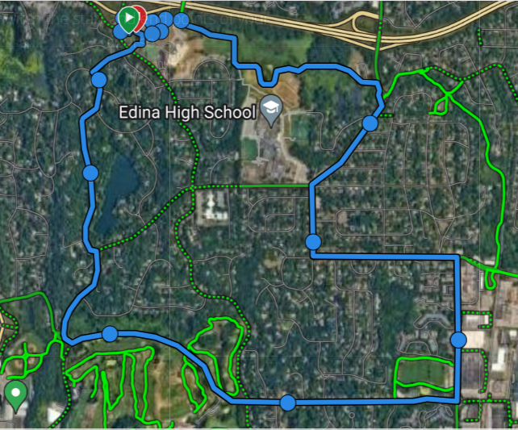
CV -> 9Mile Creek -> Valley View
-> Left: Antrim -> Left: W. 70th
-> Right: Cahill Rd
-> Right: Dewey Hill Rd
-> Becomes Hilary-> Right: Valley View
-> Left: Dakota Trail
OR
Right onto Gleason instead of Hilary.
