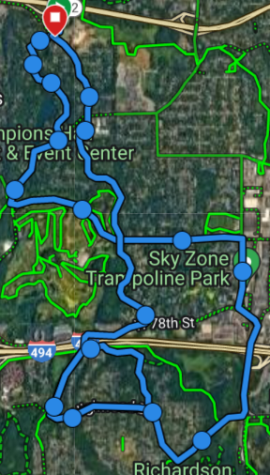
R10 Mile Training Route from CV
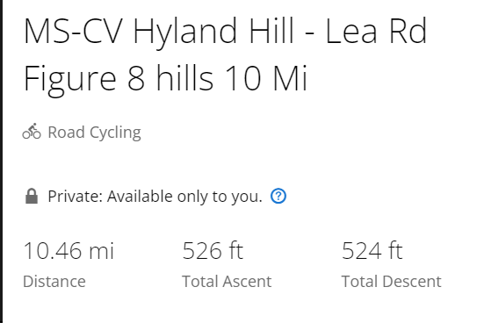

Route Summary:
CV through the neighborhoods to Hyland Bike paved trail.
South towards Hyland & East Bush Lake Road.
Traverse East along Highwood Dr to West Bush Lake Rd.
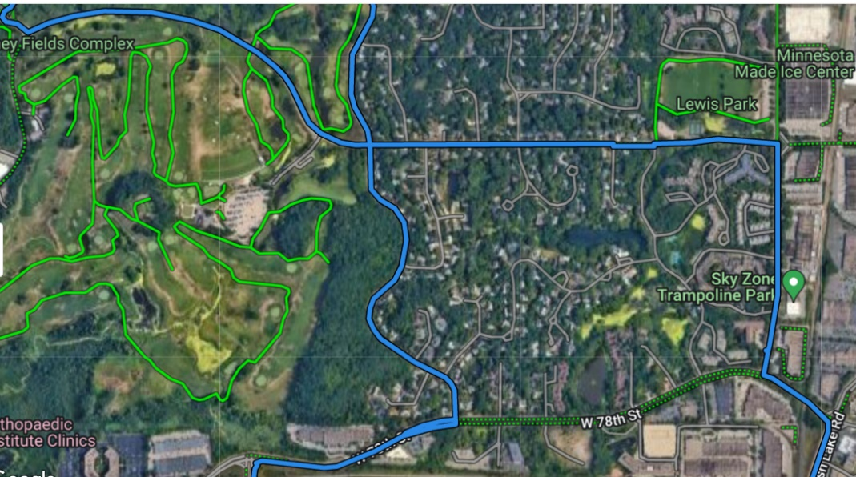
Back to Edina Via West Bush Lake road towards Braemar.

Route Details:
- CV down to Valley View
Dewy Hill
- Valley View -> Left onto Hilary Ln (along Braemar Golf Course).
- Hilary becomes Dewey Hill Rd.
Cahill
- South on Cahill
Gleason
- Left onto 78th at stoplight.
- Right onto E. Bush Lake Rd. Hop on paved trail.
W. 78th St
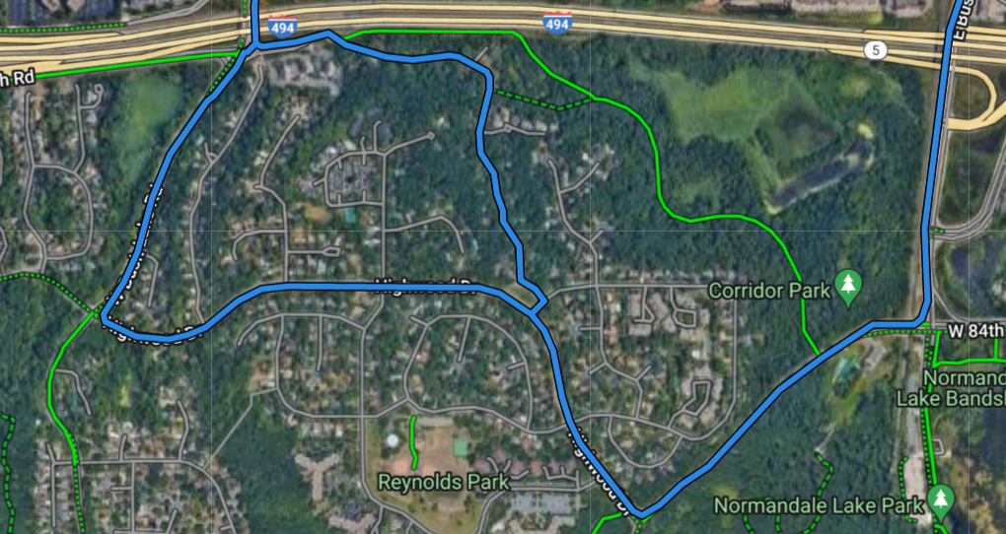
- Right on Highwood at stoplight.
- Right onto W. Bush Lake Rd.

Options:
Lea Rd. (hill option)
W. Bush Lk Rd
- Right before 494, ride Lea Rd hill.
E. Bush Lk Rd
- Ride Gravel Grinder

Back to CV:
Bike Path
- W. Bush Lk to 78th St.
- Right to GG or Gleason.
Highwood
- Gleason all the way back to CV or double back on Hilary to Valley View.

