Practice Option & Route Information: Parking at Dred Scott Park (10820 Bloomington Ferry Rd).
River Bottoms: NOTE: River Bottoms is 2-Way. Both Exits require climbing a steep road/paved trail. Lots of little “splits” in the trail, but everything heads East-West and will connect back together.
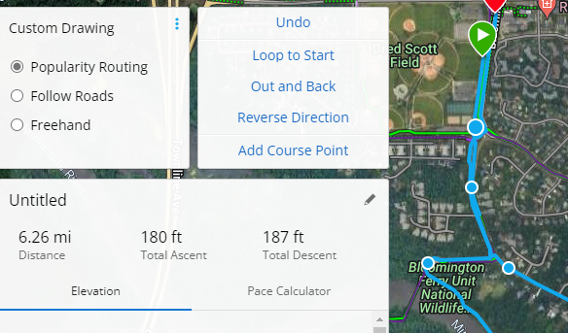
Option #1 (MS?): Dred Scott Park -> Bloomington Ferry Parking Lot (.75Mi) -> River Bottoms to 1st exit at “Swing Bridge” and Back to Dred Scott Park = Total 6.25 Mi. Very little elevation change.
Distance from Exit #1 to Dred Scott Park = 2.2 Mi or Bloomington Ferry Parking Lot to hit the trail again.
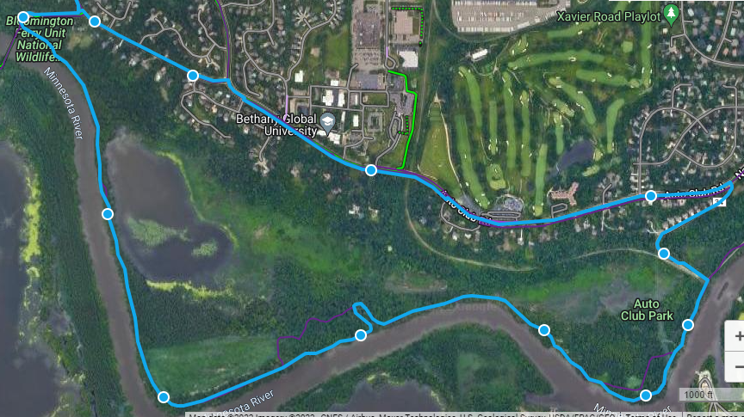
Option #2 (HS?): Continue on River Bottoms to Exit #2. Steep Hill to Exit to Overlook. 9.35 Miles Total. Distance from the top of the hill at Exit #2 back to Dred Scott Park or the Bloomington Ferry Bridge Parking lot = 4.0 Miles.
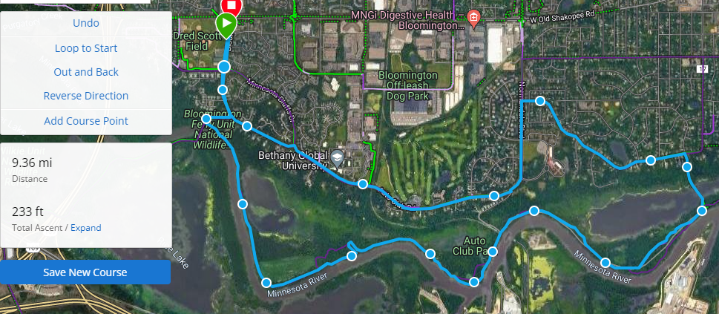
Depending on time spent at Dred Scott park, some groups could do 2 loops (2 short, or 1 of each).
Option #3 (HS/Performance?): This is only for groups able to cover a LONG distance ride. This is probably 21 – 25 miles depending on how far East of 35W you go.
River Bottoms to Exit #2 and continue East to 35W River Bottoms. 9.45 Mi to parking lot. Explore East of parking lot as time allows.
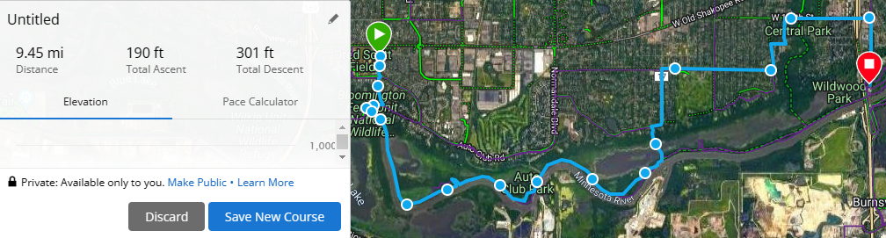

The River Bottoms continues East of 35W. The further North / Away from the river, the more elevation change. I’m not as familiar with this section. The distance from 35W parking lot to Indian Hills Park is about 3 Miles. Example below.
