LONE LAKE PRACTICE INFO – Options.
Access: 4.0 Mile bike ride from Creek Valley or park at Shady Oak Beach, only .25 mi ride to main trailhead. (DO NOT PARK AT LONE LAKE TRAILHEAD).

Note: Maximum on the trail from the team at 1 time = 40 (coaches and athletes).

Overview: Approximately 5 miles of purpose-built beginner to intermediate trail in 2 separate loops. Main loop 4 miles. 1.0 Mile loop separated by 150 feet of paved trail is close to the Rowland rd trail access (very small parking lot).

The two trail access points are connected via a paved trail (see map). This is a good option if coaches need to bounce between access points for any reason.

Paved / Road options: Lone Lake provides a great opportunity “mix it up” with a combination of dirt trail and some paved routes. This can either keep the team under the 40 person maximum and to allow for a practice with some trail practice and some solid base miles.
LRT / Crushed Gravel: accessible heading North on Rowland as marked. Can do a down-and-back heading West or Left. OR go right on the LRT and do a loop back to Shady Oak Beach.

Paved Bike Path: There is also easy access as shown on the map below to a paved trail that runs under Rowland and Hwy 62. This would be a down-and-back paved option.

Green space – Games / Skills: there is some flat green space near the main trailhead. This space includes 2 soccer fields that are often in use. There is some space to the side of the fields that is sufficient for small group games or skills practice. There is also a steep hill on the back side of the tennis courts for some hill challenges (always fun).

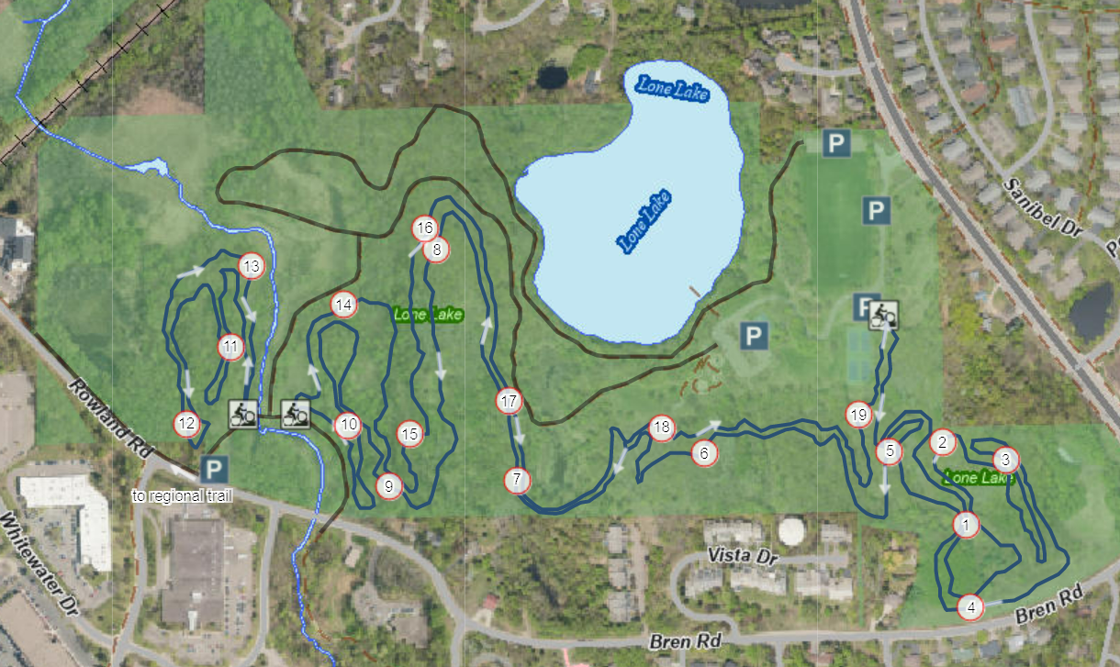

Purple line is paved trail that quickly connects the 2 loops and access points. Follow the path closest to the singletrack
Green space for games / skills and hill repeats…

Exit via small parking lot and turn right onto Rowland. LRT gravel is < 1 mile

Main trailhead access. Water available here.

Paved bike trail with tunnel under Rowland and Hwy 62. Down-and-back paved trail option.

