Wirth Practice Info – Practice Options:
Meeting Location: plan is to meet near the small parking lot just east of Wirth Beach / along Glenwood Parkway.
Although Wirth can be Very busy with Trail Kids and other High School Teams, it is a great practice option.
Trail Kids weekday sessions typically don’t start until 6:00, so an option is to roll quickly and hit some dirt right away. Below are options to mix things up, or deviate if the trails are just too crowded.

Main options of course are the many offroad trail sections along the West side of Theodore Wirth Parkway. Please familiarize yourself with the maps that can be found online. Trail sections from South to North:

Brownie: just south of 394. Please skip all technical sections other than the very 1st and last.
The Bog: Just North of 394.
Glenwood: NW quadrant of Glenwood and Wirth Parkway.
Animal Humane Society: NW quadrant of 55 and Wirth Parkway.
Back 40: accessed from paved bike path, just south of the Trailhead.
Trail 36: at the Trailhead
Conundrum (Karate Monkey): Just north of the golf course and old ski chalet.
45 North: Just north of Conundrum along the paved bike path.
Mary Hills: unofficial, but legal section. Ask one of the kids how to find this somewhat secret section.

Other Options:
- Explore over to Kenwood Neighborhood (Kenwood park has some great hilly and wide open spaces) for some hills. North Tyrol neighborhood over near Brownie has some great neighborhood hills as well.

- Explore longer road routes. Examples below are routes that head NW towards Medicine lake.

- Other Road Options: Kennilworth trail West towards Hopkins or East to the River. Can loop the South to the Greenway and return to Wirth from there.

5.8 Mile Warm-up Route - Meeting location: (East of Wirth Beach) -> to Back 40 offroad trail or back to Wirth Parkway near trailhead.
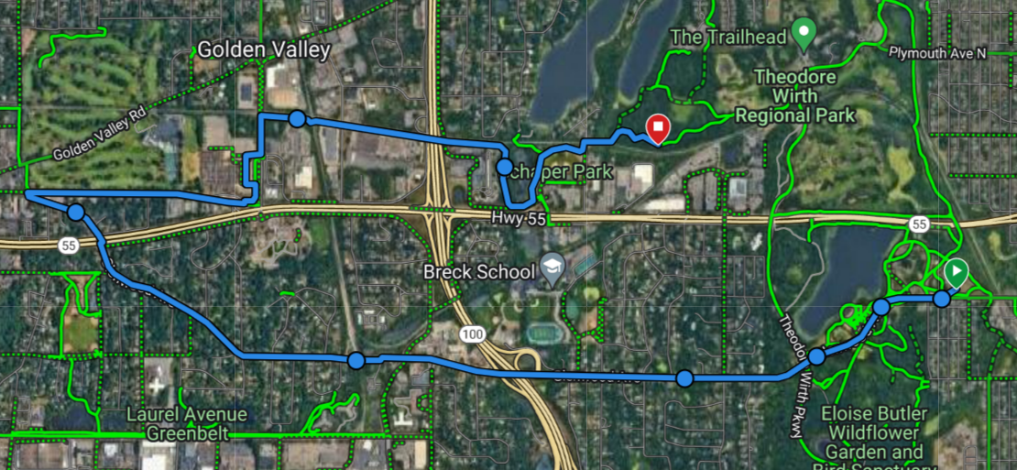

Longer Road Option from meeting spot at Wirth Beach. Lots of options: “Popsicle” to and around Medicine lake and back. GPS Routes available.
Below loop is 15 Miles.
